1. Submit a screenshot of running the “DESC <Table>;” command on each of the tables you created in “Part 4: Entity Creation Tutorial”.  
   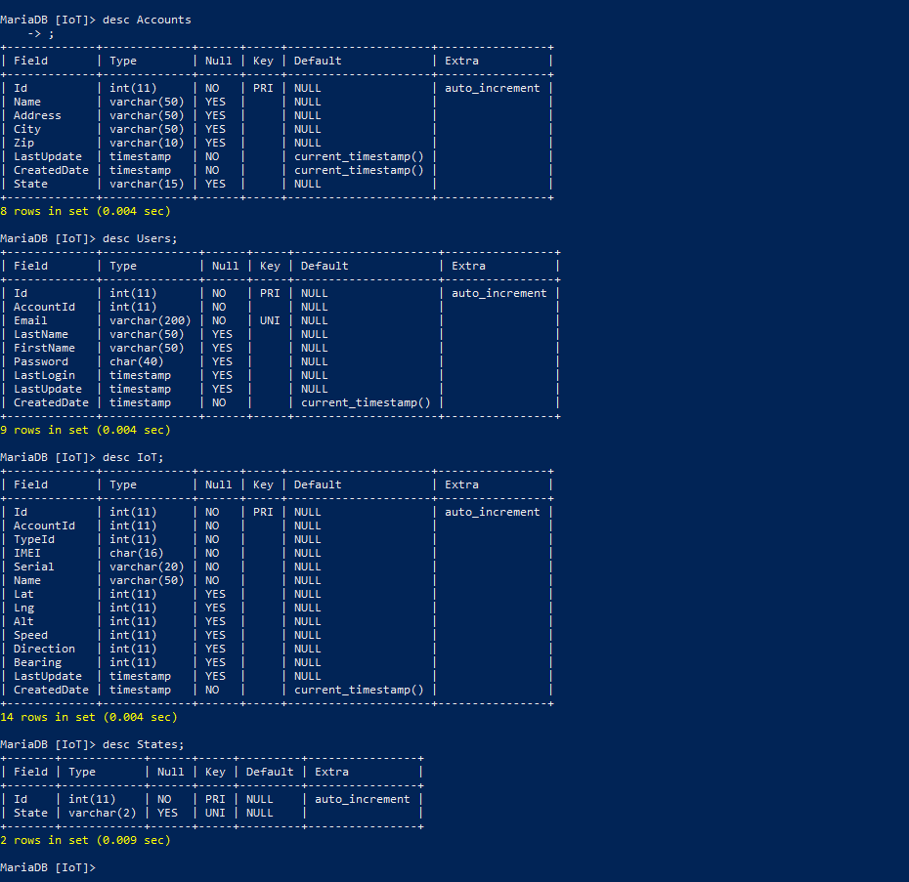
2. What is Node?  
   Node is a program that can be used to run javascript without needing to be accompanied by html code.
3. Submit a screenshot of your app_hello.js working



1. Instead of typing out all the mkdir commands in the Part 1 Web API, is there a different command you could use to just build the one directory? (Something to do with passing in an argument to create the path to the new directory?)  
   mv [file name] sictcweb/web/api/js/src/iotapi/[file name]
2. Remind me, what does IoT mean again?

Internet of Things

1. Take a screen shot of your package.json in Part 1 Web API (after you install body-pareser.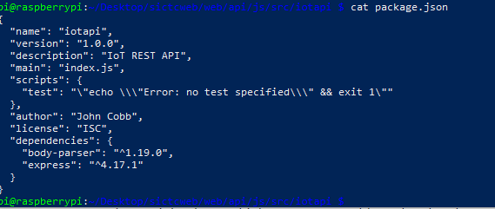
2. What does the number mean after the colon in the address <http://you-raspberry-pi-ip-address:300>

That is the port it is running on.

1. What is a JSON file?

A hash map(keyword: value) system. A file for storing info in a convenient way

1. What is the keyword to access “Classical Music” in the following JSON file? 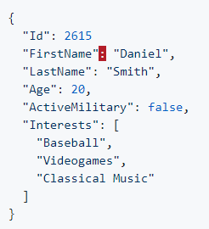

“Interests”

1. Take a screen shot of your hello-node.js working. Make sure to include both terminals.  
   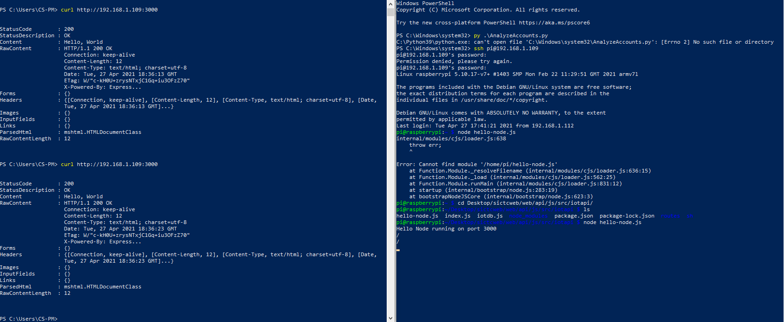

Part 2 Web API Questions

1. What does app.get method do?  
   Process request sent to our web server and responds with hello, States
2. What type of file is a .sh file?  
   Shell script
3. What is the linux command chmod doing?  
   giving files more permissions
4. Define “Design for Test”:

Methodology where each method of code has a specific test to excersize to determine the success of the output

Part 3 Web API Questions

1. Describe the purpose of each of the constants in your iotdb.js file  
   They pull the info stroed in our environment variable
2. What is configPool? Like a swimming pool? Please don’t go swimming with my Raspberry Pi’s.  
   ConfigPool stores connection information
3. What is the Python equivalent of the “try catch” method?

Try except

Take a screenshot of the command “node iotdb.js”

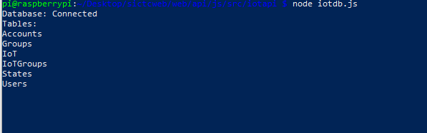  
  
Part 4 Web API Questions

1. What does the router.use method doing?  
   Tells it what route it will
2. Submit a screenshot of states.js working



1. Submit a screenshot of adding states to the db  
   
2. Submit a screenshot of deleting states to the db  
   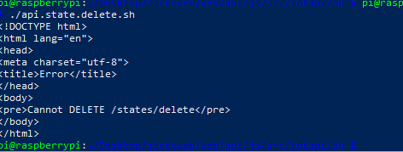
3. Submit a screenshot of getting a state to the db  
   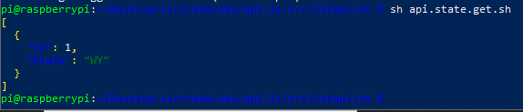
4. Submit a screenshot of updating states to the db



Part 5 Web API Questions

1. What does the router.get methods do?  
   get the route
2. What is the purpose of the constants in the file accounts.js?  
   tell the file what it needs to bring in
3. Submit a screen shot of pulling the accounts using index.js (Before the Accounts Unit Test portion).

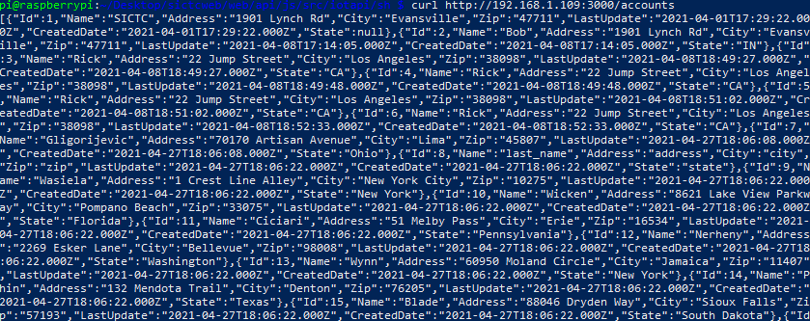

1. Submit a screenshot of adding accounts to the db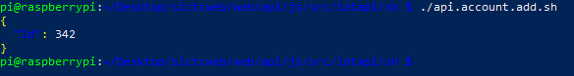
2. Submit a screenshot of deleting accounts to the db  
   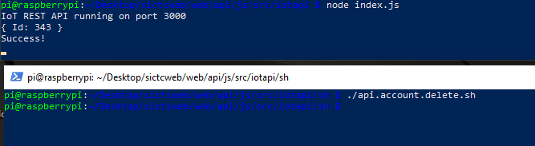
3. Submit a screenshot of getting a accounts to the db  
   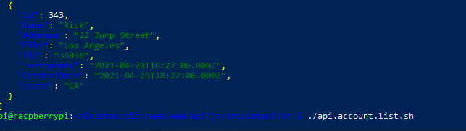
4. Submit a screenshot of updating accounts to the db

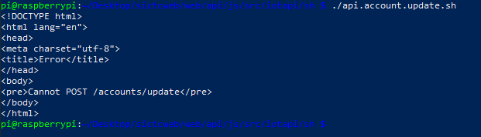

1. Submit a screenshot of your account.js showing the 6 main functions of the file

